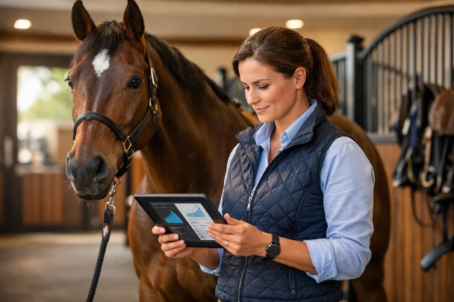
PRECISION PERFORMANCE.com.au
Elite Equine Performance
http://precisionperformance.com.au/

Disclaimer: This document is a financial projection based on the data provided. All figures are estimates and should be reviewed by a qualified financial advisor before making any business decisions.

Financial Plan & Investment Overview
This document outlines the proposed budget, investment structure, and financial projections for the new business venture. The plan is based on a total investment of $150,000.

1. Investment & Ownership Structure
The venture will be capitalized with a $150,000 investment, allocated between the concept owner and operational expenses. The ownership and profit-sharing terms are defined as follows:

Stakeholder | Ownership Stake | Key Terms & Conditions
Phillip Rankin | 60% | Stake Holder.
Investor | 40% | Corporate structure or Holding entity Structure to be advised

2. Allocation of Initial Capital
The $150,000 investment is designated for two primary purposes: clearing existing financial obligations and funding the initial operational expenses of the business for 25 Weeks.

Use of Funds
Category | Allocation | Purpose
Mgt Expenses | $50,000 | Allocated to Phillip Rankin to clear current outstanding personal debts, securing the venture's foundation.
Operational Expenses | $70,000 | Seed capital for the first 25 weeks of operation (detailed below).
Contingency | $30,000
Total Investment | $150,000

3. Projected Operational Expenses (25 Weeks)
The following table details the estimated costs for the initial 25-week period,
from March 9th, 2026, to August 31st, 2026.

Expense Category | Weekly Estimate | Total for 25 Weeks | Notes
Living & General Expenses | $1000 | $25,000 | Covers weekly stipend for the primary operator.
Fuel & Vehicle Expenses | $300 | $7500 | For travel between client stables and business meetings. Vic-Qld
Accommodation &  Meals Budget | - | $10,000 | Primarily for business travel along the NSW east coast and Sydney.
Software Construction | - | $10,000 | Development budget of the proprietary analysis and reporting software.
Communications  BE KIT Stock/Equip | - | $2,500  $5,000 | Phone internet and data hosting plans.  4 Kits and Equip held in stock at all times
Incidentals & Contingency | - | $10,000 | Reserved for unforeseen expenses and miscellaneous costs.
Total Projected Expenses |  | $70,000
Note: The total operational expense projection is $70,000.

4. Revenue Model & After 6-Month Projections
The revenue strategy is built on selling testing equipment and a recurring monthly service fee for data analysis and reporting.

Pricing Structure
Product / Service | Client Price | Details
Professional Testing Kit | $2,500 | One-time sale. Includes equipment with a 2-year guarantee.  Cost to Buyback on or before 4 weeks is $800.
Monthly Service Fee | $600 per horse | Recurring fee for 4-10 tests per week and unlimited in-house sampling. Minimum of 4 horses per stable.
Additional Horse | $500 per month | Rate for each horse added to an existing stable's plan.
Kit Replacement | $1,200 | Cost for replacing broken or damaged equipment outside of warranty. (Any broken equipment will be paid by owners - exact expense depending on which piece of equipment)

6-Month Income & Profitability Goals
The primary aim is to secure 10 trainers within the first six months, leading to the following financial targets:

Metric | Target Value | Calculation / Notes
Initial Kit Sales | $15,000 | 10 trainers purchasing one kit each at $1,500. Reduced from (RR Normally $2500.)
Weekly Income (from Week 10) | $6,000 | Based on 40 Horses/reports @$150 generated weekly via the software.
Monthly After 12 weeks  Recurring Revenue | $24,000 | $6,000 per week multiplied after 12 weeks.
Total 6-Month Revenue | $100,000 | Projected total income from all Equine sources  (25 weeks see Income sheet).
Gross Profit | $30,000 | $100,000 (Revenue) - $70,000 (Normal Operational Expenses).

5. Future Business Development
Post-launch, the focus will shift to strategic growth and operational maturity.

- Geographic Expansion: A second phase of growth will target Brisbane and Melbourne, requiring investment in travel and accommodation.
- Corporate Governance: A formal bookkeeping system will be engaged after the first six months to ensure financial compliance and reporting.
- Strategic Partnerships: The business will explore opportunities for partnerships in the equine professionals and food/supplements supply chain.
- Intellectual Property: A portion of expense funds can be itemized as "Research and Development." The company will seek official approval for its software application as research and development. Once sufficient data is collected, potentially requiring the formation of a separate legal entity.
- Branding, Marketing, testimonials, referrals and introduction at stud level and International Exposure.

Cleanskin Pty Ltd. T/A (3K)
Precision Performance P
http://precisionperformance.com.au/ (website to be developed with ecommerce etc)

Cleanskin Shareholders:
ApreC8 Pty Ltd, Equiptrade Pty Ltd, ABC Pty Ltd or equity holdings as advised by each party at time of investment/settlement
General Manager.
Phillip Rankin. CEO. Managing Director/Secretary:
New enquiries, data collection and reporting. Website and software development. Customer Relations.
Compile all relevant “Biochemistry Knowledge” into Equine Business
Title TBA:
Greg Nelson. Roll TBA – Co-Founder
Suggested roll to advise and contribute to introduction and promotion through syndicate organisations, trainers, stud farms owners etc.

